Name – Kamal D. Agrahari Subject – DevOps Lab

ID -VU4F2223028 TE IT A | Batch B

**Experiment No. 5**

**Aim** - : Executing java sequence programming and integration of GitHub with Jenkins.

**Theory** –

Jenkins:

Jenkins comes with a pretty basic setup, so you will need to install the required plugins to enable respective third-party application support.

GitHub is a web-based repository of code which plays a major role in DevOps. It provides a common platform for multiple developers working on the same code/project to upload and retrieve updated code, thereby facilitating continuous integration.

Jenkins needs to have GitHub plugin installed to be able to pull code from the GitHub repository.

Step 1: Login to Jenkins.

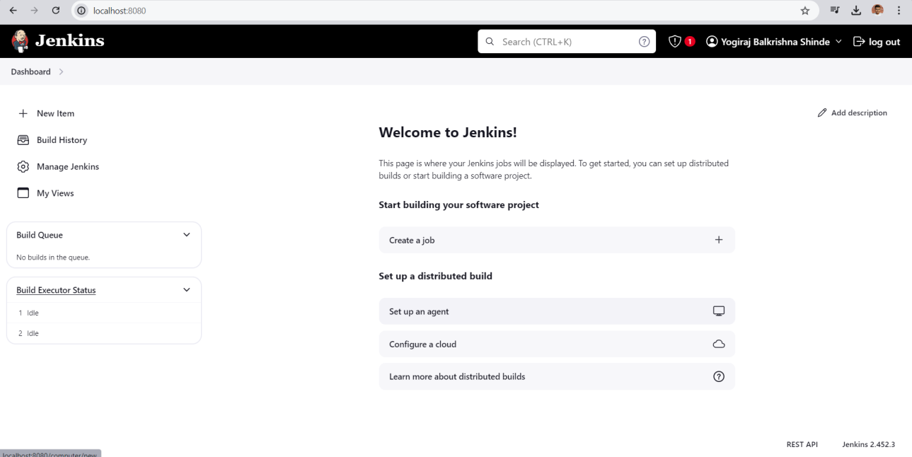

Step 2: Go to any Folder and Create one java File. 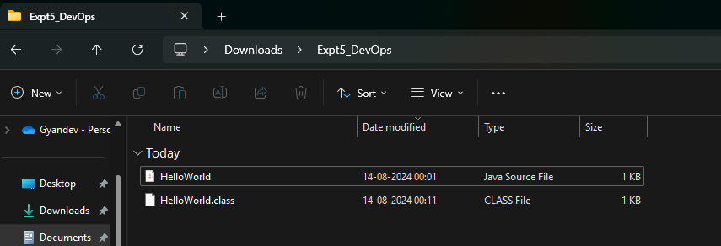

Step 3: Now create new Item.

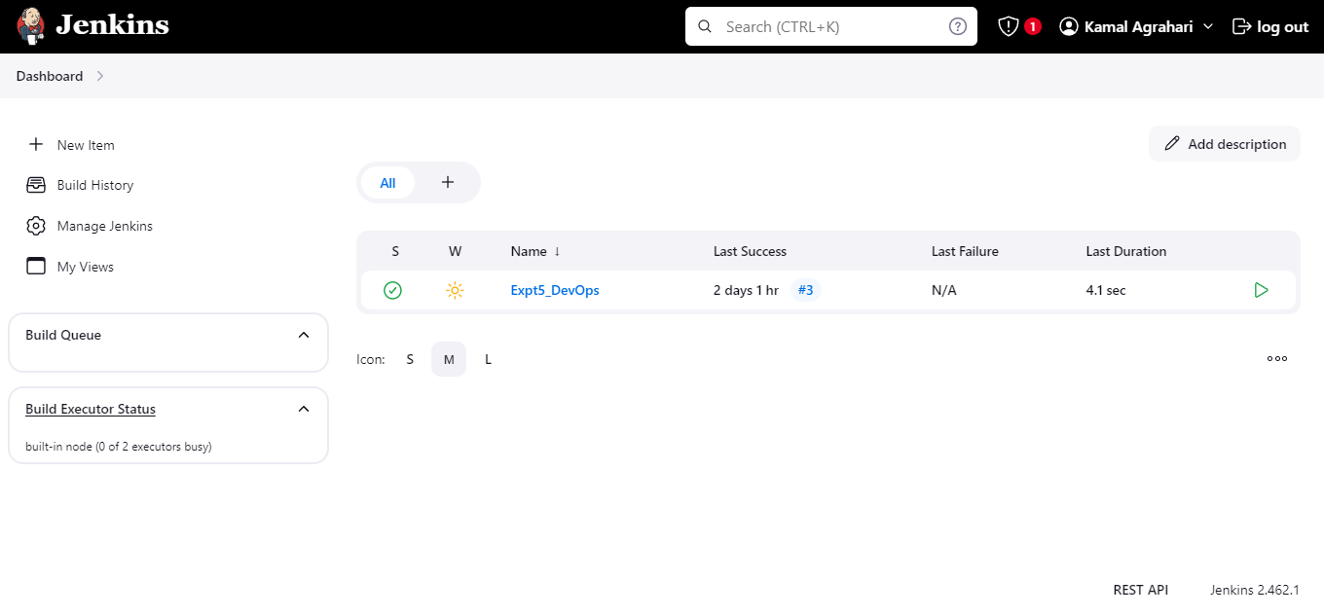Step 4: In General section. Click on “Advanced” button. Enter the location of your Java code stored in local directory in custom workspace.

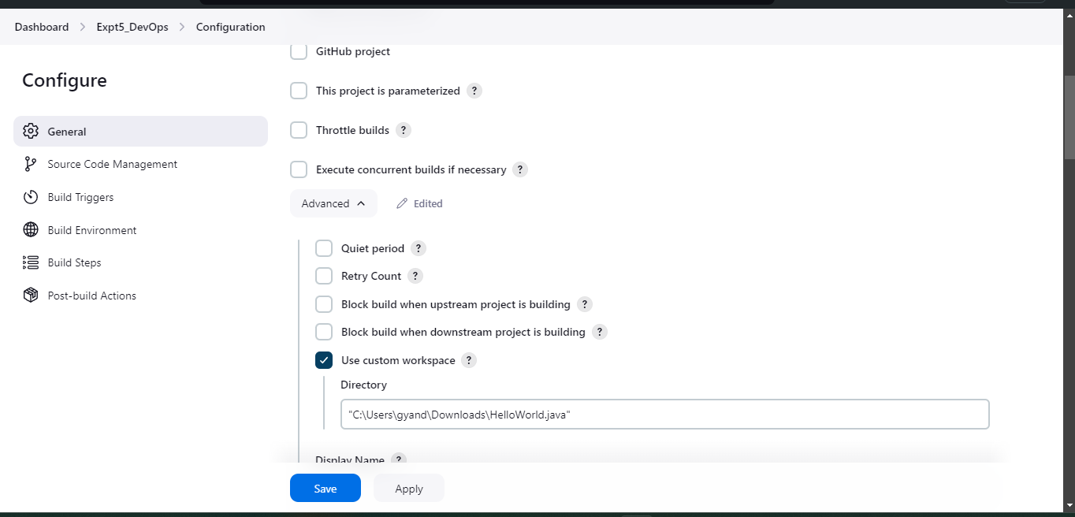

Step 5: Go to “Build” section and add build step “Execute Windows batch command”

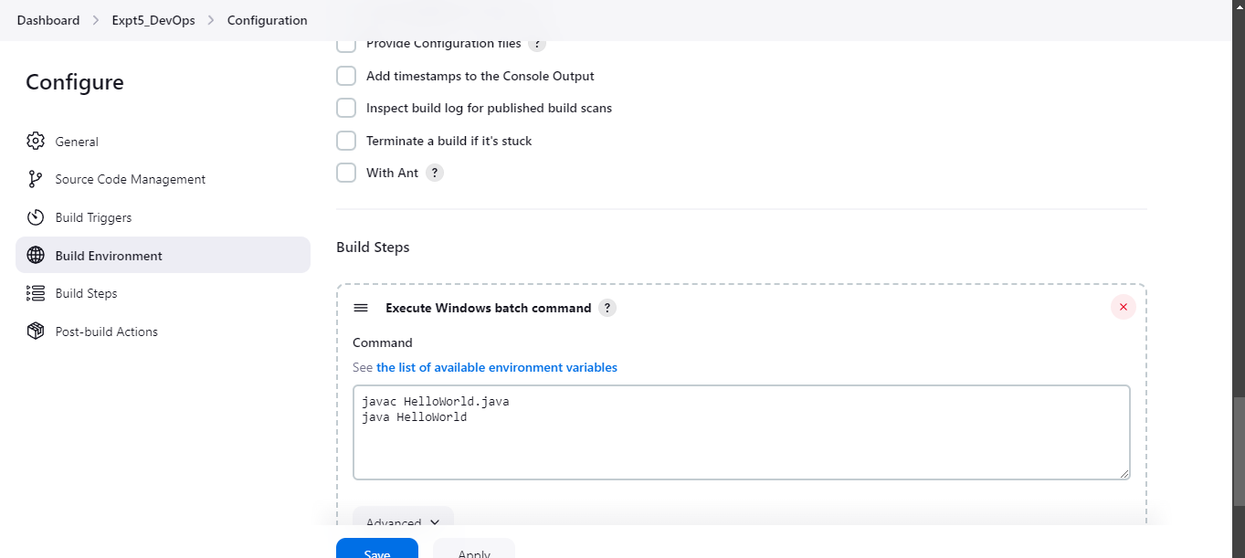

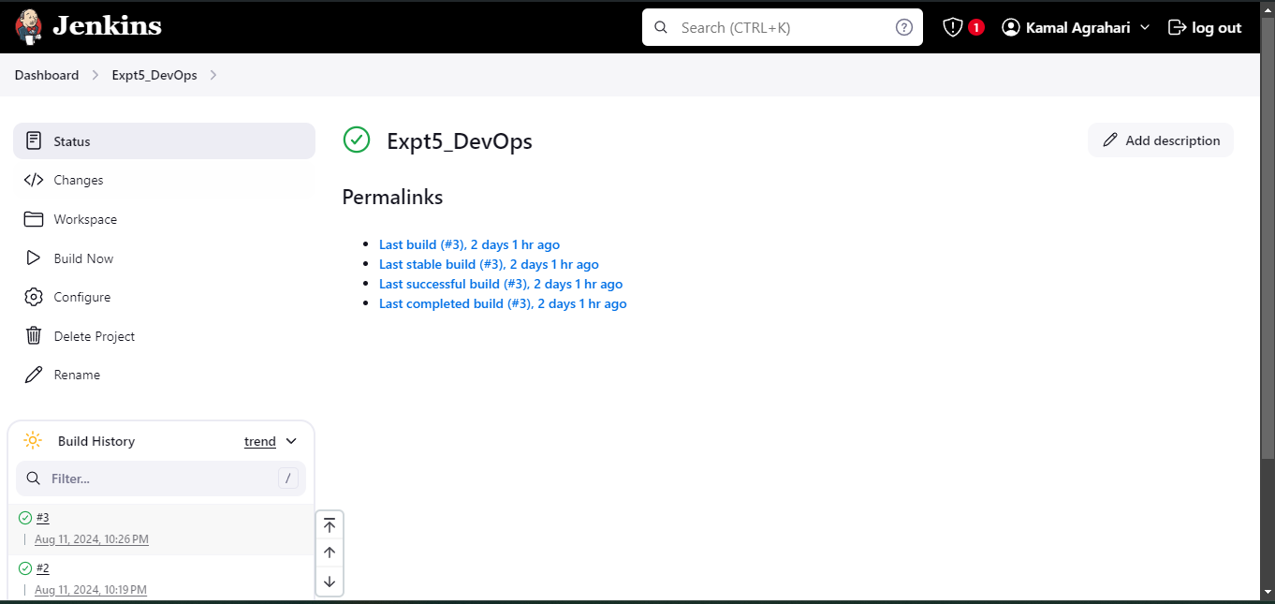

Step 6 : Execute “Hello java” by clicking on “Build Now” link. If the job is successful, then it will show Blue ball or Green tick otherwise Red ball under “Build History”

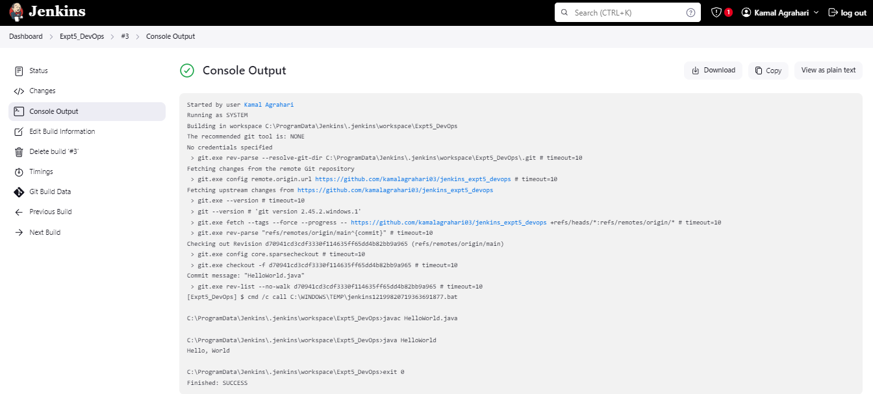

***How to Integrate Jenkins With GitHub:***

Firstly you need to install required Git plugins. Let’s proceed to the next steps for integrating Jenkins with GitHub.

Step 1: Create a new job in Jenkins, open the Jenkins dashboard with your Jenkins URL. For example, <http://localhost:8080/> Click on create new item:

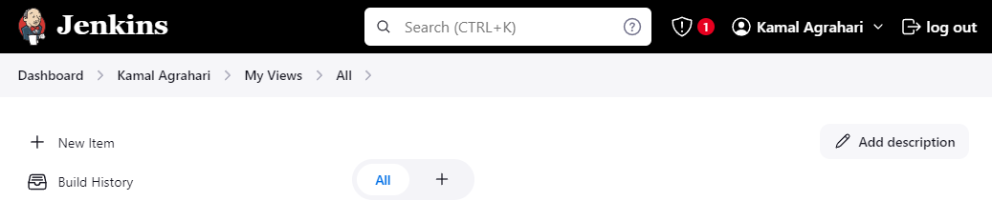

Step 2: Enter the item name select job type and click **OK**. We shall create a Freestyle project as an example.

Step 3: Once you click **OK** then the page will be redirected to its project form. Here you will need to enter the project information.

Step 4: You will see a **Git** option under **Source Code Management** if your Git plugin has been installed in Jenkins.

Step 5: Enter the Git repository URL to pull the code from GitHub:

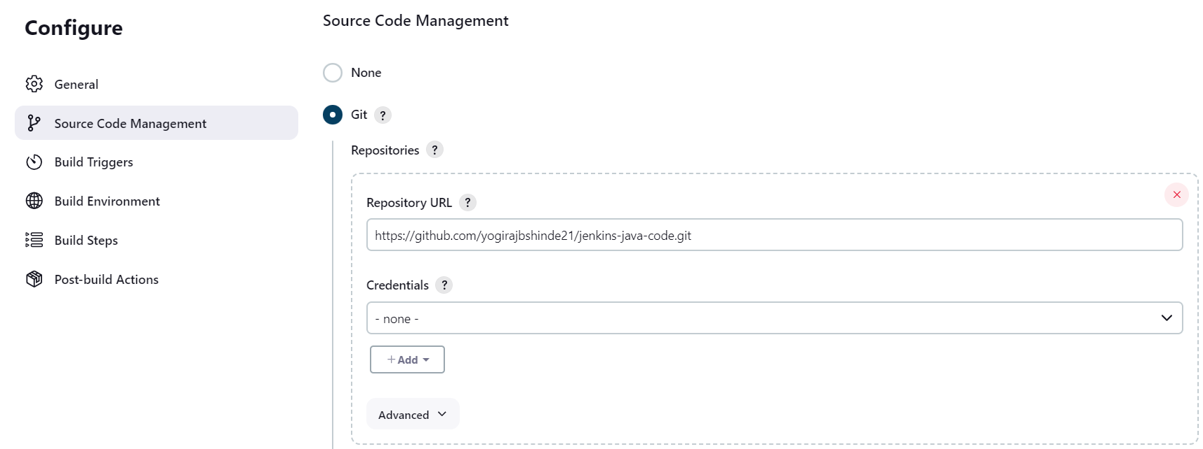

Step 6 : Go to “Build” section and add build step “Execute Windows batch command”.

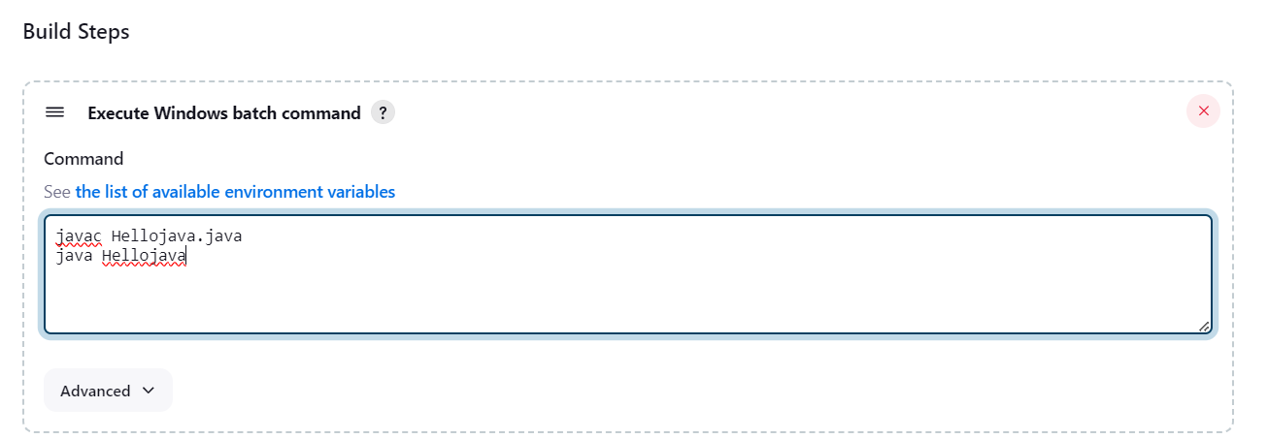

Step 7 : Click on “Build Now”. . If the job is successful, then it will show Blue ball or Green tick otherwise Red ball under “Build History”

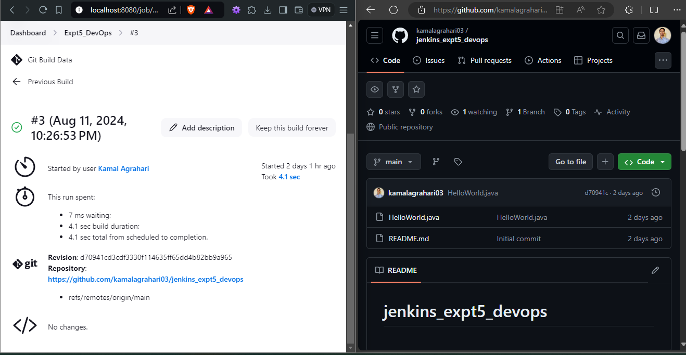

**Conclusion:**

Hence, successfully executed java sequence program IN Jenkins integrated from GitHub.